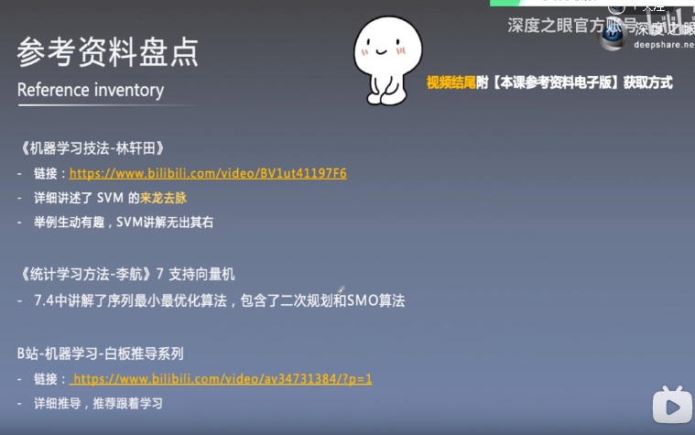

<https://www.matongxue.com/madocs/987/>

<https://www.matongxue.com/madocs/939/>

[例子：https://www.matongxue.com/madocs/2129/](https://www.matongxue.com/madocs/939/)